ORAL CANCER DETECTION USING DEEP LEARNING

A PROJECT REPORT

Submitted by
AKSHAYA.B.C 211420107004
ENUGANTI BHAVITHA 211420107008
SANGEETHA.R 211420107022

in partial fulfillment for the award of the degree of
BACHELOR OF ENGINEERING

in

ELECTRONICS AND INSTRUMENTATION ENGINEERING


PANIMALAR ENGINEERING COLLEGE
(An Autonomous Institution, Affiliated to Anna University, Chennai)

APRIL 2024

PANIMALAR ENGINEERING COLLEGE

(An Autonmous Institution, Affiliated to Anna University, Chennai)

BONAFIDE CERTIFICATE

Certified that this project report “ORAL CANCER DETECTION USING DEEP LEARNING” is the bonafide work of “AKSHAYA.B.C (211420107004) ENUGANTI BHAVITHA (211420107008) SANGEETHA.R (211420107022)” who carried out the project work under my supervision.

SIGNATURE | SIGNATURE
Dr. C. ESAKKIAPPAN, M.E., Ph.D.,  Head of the Department,  Professor,  Department of Electronics and Instrumentation Engineering,  Panimalar Engineering College, Chennai - 123 | Mr. V. VASUDHEVAN, M.E., SUPERVISOR,  Assistant Professor,  Department of Electronics and Communication Engineering,  Panimalar Engineering College, Chennai - 123

Certified that the above mentioned students were examined in Anna University project viva-voice held on _________________________.

INTERNAL EXAMINER EXTERNAL EXAMINER

ACKNOWLEDGEMENT

We would like to express our deep gratitude to our beloved Secretary and Correspondent Dr.P.CHINNADURAI, M.A., Ph.D., for his kind words and enthusiastic motivation which inspired us a lot in completing this project and we express our sincere thanks to our Directors Dr.C.SAKTHI KUMAR M.E.,Ph.d, Dr.SARANYA SAKTHI KUMAR and Mrs.C.VIJAYA RAJESWARI for providing us with necessary facilities for completion of this project.
We also express gratitude to our Principal Dr.K.MANI,M.E., Ph.D., who has been source of constant encouragement and support.
We would also like to express our gratitude to Dr.C.ESAKKIAPPAN, M.E., Ph.D., Head of the Department, Electronics and Instrumentation Engineering, for his valuable guidance, ideas and encouragement for successful completion of this project.
We would like to thank our project coordinator Dr.R.MANIKANDAN., M.E., Ph.D., and our internal guide Mr.V.VASUDHEVAN, M.E., Assistant Professor., for their valuable guidance.
We also extend our thanks to all other staff members and instructors of our department for their support towards our successful completion of project completion.
We take this opportunity to thank our beloved parents, friends and teachers for their constant support and encouragement.

CHAPTER 1
INTRODUCTION
1.1GENERAL INTRODUCTION
Cancer is a complex and multifaceted disease that arises from the disruption of the normal processes that regulate cell growth and division in the body. It can affect virtually any tissue or organ in the human body, as it originates from the uncontrolled proliferation of abnormal cells. In a healthy body, cells grow, divide, and die in a tightly regulated manner through a process called the cell cycle. This cycle ensures that new cells are produced to replace old or damaged ones, maintaining the normal functioning of tissues and organs. However, when mutations occur in the genes that control cell growth and division, this regulatory mechanism can be disrupted, leading to the development of cancer.
These mutations can be caused by a variety of factors, including genetic predisposition, environmental exposures (such as tobacco smoke, UV radiation, or certain chemicals), viruses, and lifestyle choices (such as diet, physical activity, and alcohol consumption). When cells acquire mutations that allow them to escape the normal constraints on growth and division, they can begin to proliferate uncontrollably. These abnormal cells can also acquire the ability to evade mechanisms that normally trigger cell death (apoptosis) in response to irreparable damage or stress. As a result, they accumulate in the body, forming a mass of tissue known as a tumour.
In summary, cancer is a complex disease characterized by the uncontrolled growth and spread of abnormal cells, which can arise from a variety of genetic, environmental, and lifestyle factors. Understanding the underlying mechanisms of cancer development and progression is crucial for the development of effective prevention, detection and treatment strategies.
1.2 ORAL CANCER
Oral cancer starts in the cells of the mouth. A cancerous (malignant) tumor is a group of cancer cells that can grow into and destroy nearby tissue. It can also spread to other parts of the body. The most common place where oral cancer spreads are the lymph nodes in the neck. Cells in the mouth sometimes change and do not grow or behave normally.
These changes may lead to non-cancerous tumors such as warts and fibromas. This means that the abnormal cells are not yet cancer, but there is a chance that they may become cancerous if they aren’t treated. The most common precancerous conditions of the mouth are leukoplakia and erythroplakia.
1.2.1 TYPES OF ORAL CANCER
Oral cancers include cancers of the:
- Lips
- Tongue
- Inner lining of the cheek
- Gums
- Mouth Cancer
1.2.2 SYMPTOMS OF ORAL CANCER
- A lip or mouth sore that doesn't heal
- A white or reddish patch on the inside of mouth
- Loose teeth
- A growth or lump inside your mouth
- Mouth pain
- Ear pain
- Difficult or painful swallowing
1.2.3 CAUSES
Mouth cancers form when cells on the lips or in the mouth develop changes (mutations) in their DNA. A cell's DNA contains the instructions what a cell has to do. Due to mutation the cells continue to grow and divide when healthy cells would die. The accumulating abnormal mouth cancer cells can form a tumor. With time they may spread inside the mouth and on to other areas of the head and neck or other parts of the body. Mouth cancers most commonly begin in the flat, thin cells (squamous cells) that line the lips and the inside of the mouth. Most oral cancers are squamous cell carcinomas.
  - DIAGNOSING TECHNIQUES FOR ORAL CANCER
Barium Swallow: A Barium Swallow test may show irregularities in the larynx, pharynx mouth and surrounding areas, and may often detect small, early oral tumors.
Biopsy: An oral tissue biopsy is the first step in diagnosing mouth cancer. During the biopsy, surgeon removes a small amount of abnormal tissue from the area where mouth cancer is suspected. Biopsy can confirm an oral cancer diagnosis. The types of biopsies typically used for diagnosing oral cancers are:
- Incisional Biopsy: A small piece of tissue is cut from an abnormal-looking area. If the abnormal region is easily accessed, the sample may be taken at doctor’s office. If the tumor is deeper inside the mouth or throat, the biopsy may need to be performed in an operating room, with general anesthesia administered to prevent pain.
- Exfoliative cytology: A suspicious area is gently scraped to collect a sample of cells. These cells are placed on a glass slide and stained with dye, so that they can be easily viewed under a microscope. If any cells appear abnormal, a deeper biopsy will be performed.

1.3.1 IMAGING TESTS
- Computed Tomography (CT) Scan: A CT scan may provide information about the size, shape and position of any tumors, and may also help to identify enlarged lymph nodes that may contain cancer cells.
- Magnetic Resonance Imaging (MRI): Less commonly, an MRI scan may be used to examine oral cancer. MRIs provide a very detailed view, and may be particularly useful in determining whether or not the cancer has spread, either to other areas in the neck or other regions of the body.
- Positron Emission Tomography (PET): For patients diagnosed with oral cancer, a PET scan may be used to determine whether cancer has spread to the lymph nodes first, or to check the body for the spread of cancer cells. 
- Genomic Testing for Advanced Mouth Cancer:Genomic testing is also called tumor sequencing or molecular profiling. It involves looking at the cells obtained  from a biopsy to see if there are any genetic mutations (changes in your genes) that could be linked to the type of cancer a person has.

1.4 STAGES OF ORAL CANCER

Doctors assign a stage doctor will assign a stage to cancer after physician exam and the initial results from patient’s oral tissue biopsy or imaging tests. The stage may be adjusted if one has additional tests. There are five stages of mouth cancer, starting at zero and going up to four. (They are represented by the Roman numerals I, II, III, and IV.)

Stage 0 is also called carcinoma in situ, and this is the very beginning of the scale. It describes abnormal cells in the lining of the lips or oral cavity, which have the potential to become cancer.

Stage I describes a very early stage of cancer. The tumor is not more than 2 centimeters and cancer does not reach the lymph nodes.

Stage II describes a tumor that is larger than 2 centimeters but not more than 4 centimeters and Stage II cancer does not reach the lymph nodes.

Stage III describes cancer that either is larger than 4 centimeters or has spread to a lymph node in the neck.

Stage IV is the most advanced stage of mouth cancer. It may be any of any size, but it spreads to:
- Nearby tissue, such as the jaw or other parts of the oral cavity one large lymph node (more than 3 centimeters in size) and on the same side of the neck as the tumor, multiple lymph nodes of any size on the same side of the neck as the tumor, or one lymph node of any size on the side of the neck opposite the tumor distant parts of the body beyond the mouth, such as the lungs.
- Mouth cancer may be stage IV when it is first diagnosed. Stage IV mouth cancer can also be recurrent mouth cancer not required, can be deleted. The cancer may recur in the part of the body where it originally developed (regional recurrence), in the lymph nodes (regional relapse), or in another part of the body (called distant recurrence). Stage III and stage IV cancers are more likely to recur than earlier-stage cancers.

1.4.1 ORAL CANCER: GLOBALLY
Oral cancer is one of the most common types of cancer in the world. It is a subtype of head and neck cancer, and the majority of them begin in the squamous cells that line our mouths, tongues, and lips. Oral cancer (throat) includes cancers of the lips, tongue, cheeks, mouth floor, hard and soft palate, sinuses, and pharynx. It can be fatal if not detected and treated at an early stage. Oral cancer accounts for approximately 3% of all cancers diagnosed in the United States every year, or approximately 53,000 cases per year.
According to India's 2020 Cancer Statistics Report, 66.6 percent of patients with head and neck cancer were diagnosed at a locally advanced stage. Oral cancer is characterized by inflammation or ulcers that do not heal, as well as discomfort and bleeding. A variety of behaviors, such as smoking and drinking, are risk factors for oral cancer, with these two practices being the most important. Eating worms is so common in India that it damages the insides of the gums. Globally, the crude and age-standardized rates of Oral Cavity Cancer (OCC) are 4.6 and 4 per 100,000 people, depicts the geographical variation in age-standardized rates of incidence and death around the world.
GLOBOCAN (Global Cancer Incidence, Mortality and Prevalence) predicted 354,864 new cancer cases and 177,384 cancer-related deaths in 2018, representing 2% and 1.9 percent of cancer cases and deaths, respectively. Despite various developing therapeutic techniques implemented over the last decades, the overall mortality of Oral Cavity Squamous Cell Carcinoma (OCSCC) has not decreased significantly since the 1980s.

1.5 DEEP LEARNING
Deep learning is a branch of machine learning that teaches computers to do what comes naturally to humans: learn from experience. Machine learning algorithms use computational methods to “learn” information directly from data without relying on a predetermined equation as a model. Deep learning is especially suited for image recognition, which is important for solving problems such as facial recognition, motion detection, and many advanced driver assistance technologies such as autonomous driving, lane detection, pedestrian detection, and autonomous parking. Deep learning uses neural networks to learn useful representations of features directly from data. Neural networks combine multiple nonlinear processing layers, using simple elements operating in parallel and inspired by biological nervous systems. Deep learning models can achieve state- of-the-art accuracy in object classification, sometimes exceeding human-level performance.
You train models using a large set of labelled data and neural network architectures that contain many layers, usually including some convolutional layers. Training these models is computationally intensive and you can usually accelerate training by using a high-performance GPU. This diagram shows how convolutional neural networks combine layers that automatically learn features from many images to classify new images.

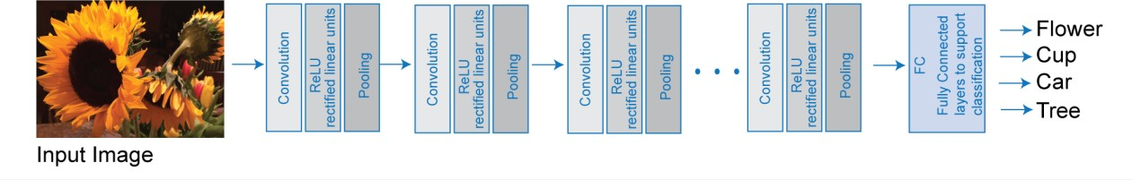

Fig 1.5 Deep Learning Diagram

Many deep learning applications use image files, and sometimes millions of image files. To access many image files for deep learning efficiently, MATLAB provides the image Data store function. Use this function to:
- Automatically read batches of images for faster processing in machine learning and computer vision applications.
- Import data from image collections that are too large to fit in memory.
- Label your image data automatically based on folder names.

1.6 TYPES OF LAYERS IN DEEP LEARNING
- Input Layer
- Convolutional Layer
- Max Pooling Layer
- Relu Layer
- Batch Normalization Layer
- Soft Max Layer
- Fully Connected Layer

1.6.1 INPUT LAYER
The input layer of a neural network is composed of artificial input neurons, and brings the initial data into the system for further processing by subsequent layers of artificial neurons. The input layer is the very beginning of the workflow for the artificial neural network.

1.6.2 CONVOLUTIONAL LAYER
Convolution is an orderly procedure where two sources of information are intertwined; it’s an operation that changes a function into something else. Convolutions have been used for a long time typically in image processing to blur and sharpen images, but also to perform other operations. (e.g., enhance edges and emboss) CNNs enforce a local connectivity pattern between neurons adjacent layers. CNNs make use of filters (also known as kernels), to detect what features, such as edges, are present throughout an image. There are four main operations in a CNN:
- Convolution
- Non-Linearity (ReLU)
- Pooling or Sub Sampling
- Classification (Fully Connected Layer)

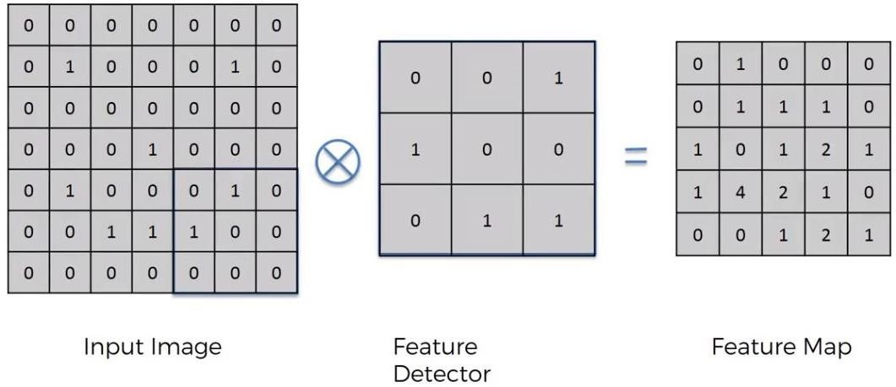
Fig 1.6.2 Convolutional Layer In DL

1.6.3 MAX POOLING LAYER
Max Pooling is a convolution process where the Kernel extracts the maximum value of the area it convolves. Max Pooling simply says to the Convolutional Neural Network that we will carry forward only that information, if that is the largest information available amplitude wise. Max- pooling on a 4*4 channel using 2*2 kernel and a stride of 2: As we are convolving with a 2*2 Kernel. If we observe the first 2*2 set on which the kernel is focusing the channel have four values 8,3,4,7. Max-Pooling picks the maximum value from that set which is “8”.

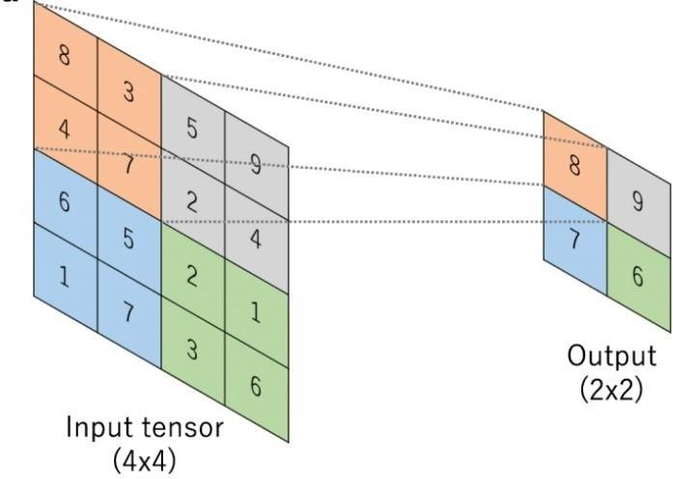

Fig 1.6.3 Max pooling Layer in DL

Here in our context, we will make a kernel that amplifies the image of the cat’s eye to such an extent that even after Max Pooling the predominant information is not lost. When Max Pooling now clips my pixels, the 25% pixels which are left are enough to get the information about the cat. So, there is going to be one channel or feature map which contains the information of the cat’s eye no matter what happens at the benefit of reducing 75% pixels. In another way, we can say that we are filtering information that we don’t want by building Kernels which can allow getting required information out through Max Pooling.

1.6.4 RELU LAYER

In the context of artificial neural networks, the rectifier or ReLU (Rectified Linear Unit) activation function is an activation function defined as the positive part of its argument:
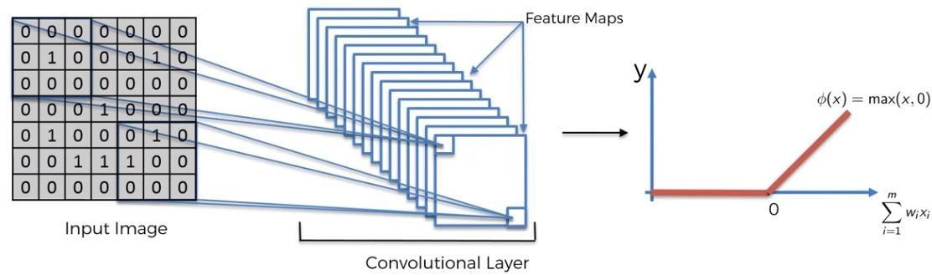

Fig 1.6.4 ReLU Layer in DL
where x is the input to a neuron. This is also known as a ramp function and is analogous to half-wave rectification in electrical engineering. This activation function started showing up in the context of visual feature extraction in hierarchical neural networks starting in the late 1960s. It was later argued that it has strong biological motivations and mathematical justifications. In 2011 it was found to enable better training of deeper networks, compared to the widely used activation functions prior to 2011, e.g., the logistic sigmoid (which is inspired by probability theory; see logistic regression) and its more practical counterpart, the hyperbolic tangent. The rectifier is, as of 2017, the most popular activation function for deep neural networks. Rectified linear units find applications in computer vision and speech recognition using deep neural nets and computational neuroscience.

1.6.5 BATCH NORMALIZATION LAYER
Training deep neural networks with tens of layers is challenging as they can be sensitive to the initial random weights and configuration of the learning algorithm. One possible reason for this difficulty is the distribution of the inputs to layers deep in the network may change after each mini-batch when the weights are updated. This can cause the learning algorithm to forever chase a moving target. This change in the distribution of inputs to layers in the network is referred to the technical name “internal covariate shift.” Batch normalization is a technique for training very deep neural networks that standardizes the inputs to a layer for each mini-batch. This has the effect of stabilizing the learning process and dramatically reducing the number of training epochs required to train deep networks. In this post, you will discover the batch normalization method used to accelerate the training of deep learning neural networks.
- Deep neural networks are challenging to train, not least because the input from prior layers can change after weight updates.
- Batch normalization is a technique to standardize the inputs to a network, applied to ether the activations of a prior layer or inputs directly.
- Batch normalization accelerates training, in some cases by halving the epochs or better, and provides some regularization, reducing generalization error.

1.6.6 SOFT MAX LAYER
From the figure about the detection of the dog, we found 0.95 Dog, and 0.05 Cat. The question is how these two values add up to 1. That is possible only introducing the SoftMax Function, the formula is the following:

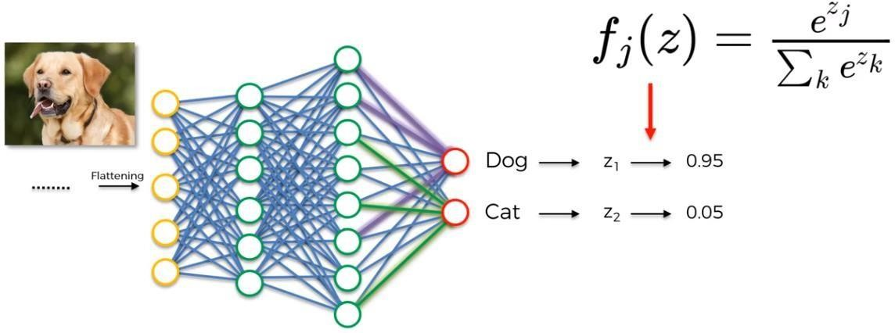

Fig 1.6.6 SoftMax Layer in DL

As described by the formula in the figure above, the SoftMax Function is a generalization of the Logistic Function, and it makes sure that our prediction adds up to 1. Most of the time the Soft max Function is related to the Cross Entropy Function. In CNN, after the application of the Soft max Function, is to test the reliability of the model using as Loss Function the Cross Entropy Function, in order to maximize the performance of our neural network. There are several advantages to using the Cross Entropy Function. One of the best is that if for instance at the start of back propagation the output value is much smaller than the actual value, the gradient descent will be very slow. Because Cross Entropy uses the logarithm, it helps the network to assess even large errors.

1.6.7 FULLY CONNECTED LAYER

The Flattened vector that we described above, now is used as an input in a Fully Connected ANN. With fully connected we mean that the hidden layer is fully connected. This is by definition a CNN. The purpose of this is to combine our features into more attributes to predict the classes even better. In fact, combining more attributes (e.g., edge detect, blur detect, emboss detect) help to predict better the images. The figure below shows as an example the neurons activated for a Dog.

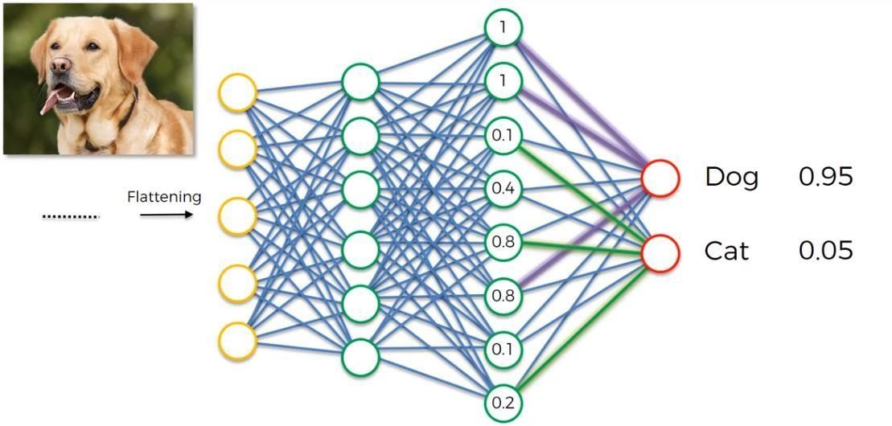

Fig 1.8.7 Fully Connected Layer in DL

The links between neurons and output colored in violet for dog, and green for cat, tell us which are the important neurons for dog and cat respectively. The figure below, summarize all the steps till now considered.

1.6.8 SUMMARY OF ALL LAYERS IN DL

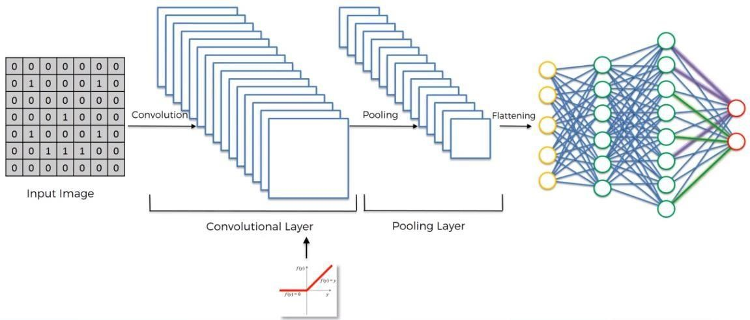

Fig 1.6.8 Summary of all Layers in DL

CHAPTER 2
LITERATURE SURVEY
Table 2.1: Summary of Existing Work
Title | Authors | Publisher | Year | Algorithms Used/ Achievements | Limitations
Advanced Meta-Heuristic  Algorithm Based on Particle  Swarm and Al-Biruni Earth  Radius Optimization  Methods for Oral Cancer  Detection | H. Myriam; A. A.  Abdelhamid; E. -S.  M. El-Kenawy; A.  Ibrahim; M. M. Eid;  M. M. Jamjoom; D.  S. Khafaga | IEEE | 2023 | -Convolutional Neural Network (CNN) and  optimized Deep Belief Network (DBN).  - Development of a hybrid optimization algorithm  (PSOBER) combining Particle Swarm Optimization  (PSO) and Al-Biruni Earth Radius (BER)  Optimization.  - Achieved an accuracy of 97.35% on a standard  biomedical images dataset from Kaggle. | - Reliance on a single dataset may limit  generalizability.  - Further validation on larger datasets is necessary.  - Limited exploration of additional oral  features for cancer detection.
Multimodal Transfer  Learning for Oral  Presentation Assessment | S. S. Y. Tun; S.  Okada; H. -H.  Huang; C. W. Leong | IEEE | 2021 | The paper employs transfer learning techniques to  leverage knowledge from a job interview dataset  for pretraining and then adapt it to a smaller  presentation dataset. This approach aims to  enhance the learning process and improve  performance in evaluating oral presentation skills | The transferability of knowledge  between the job interview dataset and  the presentation dataset might be  limited by domain-specific nuances.  Certain aspects of oral communication  and performance evaluation may differ  between these contexts, potentially  impacting the generalization capability of  the model.
Unveiling the Future of Oral  Squamous Cell Carcinoma  Diagnosis: An Innovative  Hybrid AI Approach for  Accurate Histopathological  Image Analysis | I. U. Haq; M.  Ahmed; M. Assam;  Y. Y. Ghadi; A.  Algarni | IEEE | 2020 | This approach combines Gabor filtering, which is  effective in texture analysis, with CatBoost, a  gradient boosting algorithm known for its  robustness and efficiency in classification tasks.  While specifics on the achieved performance  metrics are not provided, this method likely yielded  promising results given its utilization of both  low-level feature extraction and advanced machine  learning techniques. | The study does not provide information  on the diversity of datasets used for  training and testing. It is essential to  assess the algorithm's performance on  diverse datasets to ensure its  generalizability across different  populations, imaging conditions, and  equipment.
Aligning Small Datasets  Using Domain Adversarial  Learning: Applications in  Automated in Vivo Oral  Cancer Diagnosis | K. Caughlin; E.  Duran-Sierra; S.  Cheng; R. Cuenca; B.  Ahmed; J. Ji; M.  Martinez; M.  Al-Khalil; H. Al-Enazi;  Y. -S. L. Cheng; J.  Wright; J. A. Jo; C.  Busso | IEEE | 2020 | Integration of a domain adaptation module into the  neural network architecture to encourage domain  invariance between two multispectral  autofluorescence imaging (maFLIM) datasets. | Incorporating domain adaptation  techniques into the neural network  architecture increases computational  complexity and training time, which may  hinder scalability and deployment in  real-world clinical settings with limited  computational resources.
A Multifaceted Approach to  Oral Assessment Based on  the Conformer Architecture | Z. Fan; J. Li; A.  Wumaier; Z. Kadeer;  A. Abdurahman | IEEE | 2019 | This method effectively increases the model's  ability to capture local feature information at  different scales, enhancing the model's  performance in mispronunciation detection and  pronunciation quality assessment tasks. | The experiments are conducted on  self-built and open-source datasets,  which may not fully represent the  diversity of real-world speaking  scenarios. The generalizability of the  proposed method to other languages  and dialects remains uncertain.
The Minimally-Invasive  Oral Glucose Minimal  Model: Estimation of  Gastric Retention, Glucose  Rate of Appearance, and  Insulin Sensitivity from  Type 1 Diabetes Data  Collected in Real-life  Conditions | E. Faggionato; M.  Schiavon; L.  Ekhlaspour; B. A.  Buckingham; C.  Dalla Man | IEEE | 2018 | This method was utilized to identify the parameters  of the Oral Minimal Model (OMM) and the  physiological model of glucose transit through the  gastrointestinal tract (R-OMM) from plasma glucose  (G) and insulin (I) measurements. | The study's sample size of forty-seven  individuals with type 1 diabetes may not  fully capture the variability present in the  population, limiting the generalizability  of the findings.

2.1 LIMITATIONS :
Limited Data: CNNs require large amounts of labeled data to train effectively. In the case of oral cancer detection, obtaining sufficient data for training can be challenging due to privacy concerns, the need for expert annotations, and the variability in imaging quality.
Overfitting: CNNs are prone to overfitting, especially when dealing with small datasets. This means the model may learn to recognize specific features present in the training data that do not generalize well to new, unseen data. In medical imaging, overfitting can lead to inaccurate predictions when applied to real-world scenarios.
False positives and false negatives: Like any diagnostic tool, CNN-based oral cancer detection systems are susceptible to false positives (incorrectly identifying non-cancerous lesions as cancerous) and false negatives (missing cancerous lesions). These errors can have serious consequences, leading to unnecessary biopsies or missed diagnoses

CHAPTER 3
EXISTING SYSTEM
3.1 CONVOLUTIONAL NEURAL NETWORK (CNN)
The number of parameters essential to train a fully connected network is much larger than CNN. Further, in majority of images, the neighboring pixels are generally related, but a fully connected neural network doesn’t consider this, while a CNN takes into account our sense of space and pixel affiliation in an image. Using accustomed neural networks for real-world image classification is unworkable for the following reason: Consider a 2D image of size 200x200 for which there would be 40,000 input nodes. If the hidden layer has 20,000 nodes, the size of the matrix of input weights would be 40,000 x 20,000 =800 million. This is just for the first layer, as we increase the number of layers, this number will increase even more swiftly. Besides, vectorizing an image ignores the image's complex 2D spatial structure. How do we build a system that overcomes both these disadvantages? One way is to use 2D convolutions rather than matrix multiplications. Learning a set of convolutional filters (each of 11 × 11, say) is much more tractable than learning a large matrix (40,000 × 20,000). 2D convolutions also naturally take the 2D structure of images into account. Alternately, convolutions can also be thought of as regular neural networks with two restrictions. They are local connectivity and weight 5 sharing, where the filter moves one position to the right with each multiplication that may not practically apply the convolution activities on CNN. Rather, bigger changes which are frequently referred to as strides, are usually used. This is similar to image down- sampling. CNN's architecture is similar to that of the human brain connectivity model of neurons. There are some strong preferences embedded in CNN based on how they are constructed, which helps to understand why they are so powerful. As depicted the building blocks of CNNs. building blocks of convolutional networks.
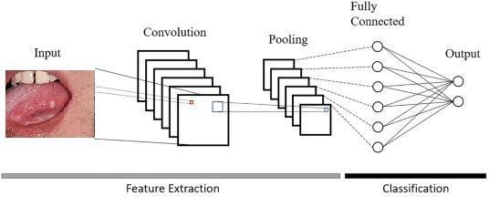

Fig 3.1: A CNN Architecture

When applying neural networks to images one can in principle use the simple feed forward neural networks. However, having connections from all nodes of one layer to all nodes in the next is extremely inefficient. Careful pruning of the connections based on domain knowledge, i.e. the structure of images, leads to much better performance. A CNN is a particular kind of artificial neural network aimed at preserving spatial relationships in the data, with very few connections between the layers. The input to a CNN is arranged in a grid structure and then fed through layers that preserve these relationships. Each layer operating on a small region of the previous layer. CNNs can form the highly efficient representation of the input data, well-suited for image-oriented tasks. A CNN has multiple layers of convolutions and activations, often interspersed with pooling layers, and is trained using back propagation and gradient descent similar to the standard artificial neural networks. Besides, CNN typically has fully connected layers at the end, which compute the final outputs .
- Max-Pooling: Each feature map produced by feeding the data through one or more convolutional layer is then typically pooled in a pooling layer. Pooling operations take small grid regions as input and produce single number for each region. The number is usually computed by using the max function (max-pooling) or the average function (average pooling). Since a small shift of the input image results in small changes in the activation maps, the pooling layers give CNN some translational invariance. A different way of getting the down sampling effect of pooling is to use convolutions with increased stride lengths. Removing the pooling layers simplifies the network architecture without necessarily sacrificing performance. Other variant of pooling include average-pooling, winner-takes-all pooling, and stochastic pooling. However, Max-pooling is most commonly used among all these pooling methods.
- Fully-Connected Layers: Neural networks are traditionally been comprised of multiplications of matrixes, alternating with nonlinearities such as sigmoid. These matrix multiplication layers are called a fully-connected layer, such that each unit of the previous layer is connected to every unit of the next layer. The huge difference that a neural network shows with convolutional layers, that there is only a local spatial connection. In modern networks, the huge numbers of fully connected layers are generally avoided as they use enormous parameters.
- Depth: The Universal Approximation Theorem says that any continuous function can be modeled by a neural network with a single hidden layer. However, on the contrary to a neural network with many hidden layers, it has been shown that such networks need an exponentially sizable neurons.

  - Limitations of Existing Systems: Current oral cancer detection systems often suffer from shortcomings in accuracy and robustness due to their reliance on either clinical data or image analysis alone.
1.Suboptimal Performance: Traditional methods may fail to achieve optimal performance due to the complexity and variability of oral cancer manifestations.
2.Challenges in Feature Representation and Integration: Existing systems may struggle with effectively representing and integrating features from both clinical data and image analysis, which is essential for distinguishing between cancerous and non-cancerous cases.
3.Need for Comprehensive Evaluation: The lack of comprehensive evaluation using standard metrics may undermine the reliability of results obtained from existing systems.
4.Call for Advanced Approaches: These limitations underscore the necessity for more advanced approaches that combine deep learning architectures with traditional techniques.
5.Objective of Improving Accuracy and Reliability: The primary goal is to enhance the accuracy and reliability of oral cancer detection systems by addressing the limitations of current approaches.
6.Integration of Deep Learning and Traditional Techniques: The proposed approach involves combining deep learning architectures with traditional methods to leverage their respective strengths and overcome existing limitations.

3.3 Scope

The above inferences were drawn from the literature survey and thus the
following scope has been drawn:
- Artificial intelligence may be a novel and effective tool for detecting oral cancer at an early stage.
- Deep Learning methods are used for the diagnosis of Oral Cancer.
- Oral cancer is diagnosed via a painless diagnostic procedure.
- A non-invasive way of diagnosis, i.e. an automatic diagnosis approach for oral cancer, will be introduced.
- Using a dynamic pre-processing technique, image feature extraction and normalization will be performed.
- Transfer learning enables developers to use a combination of models to fine-tune a solution to a given problem.
- An optimizer is a function or algorithm that adjusts the neural network's properties such as weights and learning rate. As a result, it helps to reduce total loss and enhance accuracy.

CHAPTER 4
PROPOSED SYSTEM
4.1 MODULES
DATA COLLECTION
DATA PREPROCESSING

IMAGE SEGMENTATION

CLASSIFICATION

PREDICTION

Fig 4.1 Modules Flowchart

    - MODULE 1: DATA COLLECTION
- This module focuses on gathering a comprehensive and diverse dataset of oral images. It involves the systematic collection of images representing various stages of oral cancer and normal oral tissues. The dataset should be well-curated to ensure its representativeness and suitability for training a deep learning model.
- Data collection process involves gathering a diverse range of oral images along with associated clinical information. This includes acquiring images of oral lesions, biopsies, patient demographics, medical history, and diagnostic outcomes. Data sources may include medical imaging repositories, hospitals, clinics, and research databases. Ethical considerations regarding patient privacy and consent must be adhered to throughout the data collection process.

4.1.2 MODULE 2: DATA PRE-PROCESSING
In this module, the collected dataset undergoes preprocessing steps to standardize and enhance its quality. Image preprocessing techniques, such as resizing, normalization, and augmentation, are applied to ensure uniformity and improve the model's ability to generalize to different conditions
1. Median Filter: Apply a median filter to reduce noise and enhance image clarity, which helps in improving the quality of input images for further analysis.
2. TOPHAT Model: Utilize the TOPHAT transformation to enhance the contrast of oral images, highlighting subtle details that may be indicative of abnormalities.
4.1.3 MODULE 3: IMAGE SEGMENTATION
Segmentation is a crucial step in analyzing medical images such as oral images, as it involves dividing the images into meaningful regions or segments for further analysis. In this module, the MS-ROI (Multi-Scale Region of Interest) model is employed to perform image segmentation, specifically focusing on identifying regions of interest that may contain lesions or abnormalities in oral images.
Employing the MS-ROI (Multi-Scale Region of Interest) Model:
The MS-ROI model operates by analyzing the oral images at multiple scales, enabling it to capture both global and local features of the images. This approach enhances the model's ability to detect subtle abnormalities and lesions that may vary in size and appearance.
a. Multi-Scale Analysis: The MS-ROI model employs a multi-scale analysis technique to analyze the oral images at different resolutions or levels of detail. This allows the model to capture fine details as well as larger-scale patterns present in the images.
b. Region of Interest Identification: By analyzing the image at multiple scales, the MS-ROI model identifies regions within the oral images that exhibit characteristics indicative of lesions or abnormalities. These regions are marked as regions of interest for further examination.
c. Segmentation and Isolation: Once the regions of interest are identified, the MS-ROI model segments these regions from the background, isolating them for closer inspection. This segmentation process ensures that only relevant areas of the oral images are considered for further analysis.
d. Output: The output of the MS-ROI model includes segmented images with highlighted regions of interest, providing valuable visual cues to healthcare professionals for identifying and diagnosing oral lesions and abnormalities.
4.1.4 MODULE 4: CLASSIFICATION
- Classification involves categorizing segmented regions as either cancerous or non-cancerous based on extracted features.
1. Feature Extraction: Utilize deep learning architectures such as RNN, LSTM, GRU, GAN, and autoencoders to extract relevant features from segmented regions.
2. Traditional Machine Learning Techniques: Apply traditional machine learning algorithms such as SVM, Random Forest, or k-NN for feature representation and classification.
3. Feature Fusion: Combine features extracted from both image data and clinical information to create a comprehensive feature representation for classification.
4. Classification Model Training: Train a classification model using the extracted features to distinguish between cancerous and non-cancerous cases.
4.1.5 MODULE 5: PREDICTION
- Prediction involves deploying the trained classification model to predict the likelihood of oral lesions being cancerous.
1.Model Evaluation:
Assess the performance of the trained classification model using standard evaluation metrics such as accuracy, sensitivity, and specificity.
2. Prediction on New Data:
Apply the trained model to new oral images and clinical data to predict the presence of oral cancer and provide early diagnosis and intervention recommendations.

4.3 IMPLEMENTATION DETAILS

4.3.1 Data Collection
The Histopathologic Image was obtained from the Kaggle Dataset, which contains 2494 normal images and 2698 images affected by oral cancer, as well as real-time images, which contain 44 normal images and 87 oral cancer affected images.
S.No | Dataset Name | Dataset Link
1 | Histopathologic Oral Cancer Detection | https://www.kaggle.com/ashenafifasilkebede/dataset
2 | Oral Cancer (Lips and Tongue) images | https://www.kaggle.com/shi17299/oral-cancer-lips- and-tongue-images

4.3.2 Pre-Processing
Pre-processing is the process of improving a data image by removing undesired distortions and enhancing some image attributes that are crucial for further image processing. There are three main processes in image pre-processing.
- Data Loading and Cleaning
- Removal of NAN values remove noise signal
- Data loading and Cleaning: - The first step is to import the libraries that will be required by the programme. Initially, OpenCV, and Mulis libraries were used to pre-process various oral cancer and non-cancer images A library is essentially a collection of modules that can be called and used, and data cleaning is done after data loading, which involves fixing or eliminating incorrect, corrupted, incorrectly formatted, duplicate, or incomplete data from a dataset. When combining various data sources, there are numerous possibilities for data to be duplicated or mislabelled. Even if the data is correct, the results and algorithms are untrustworthy if the data is incorrect. There is no one-size-fits-all strategy to prescribing the specific phases in the data cleaning process because the methodologies will differ from dataset to dataset. However, it is vital to build a template for the data cleaning operation so that one can be certain that are performing it right each time.
- Removal of NAN values: - NAN values are those that are not a number. The rows or columns with null values can be deleted to deal with the missing values. If more than half of the rows in a column are null, the column can be dropped entirely. The rows with null values in one or more columns can also be removed. The NAN values are removed in this process.
- Removal of Noise Signals: - After the removal of NAN values the Noise is removed from the images i.e noise from a signal. The noise removal algorithms reduce or remove the visibility of noise by smoothing the entire image leaving areas near contrast boundaries.

4.3.3 Exploratory Data Analysis: - After pre-processing the images from both the datasets, the information was summed and presented graphically using the histogram. R represents red, G refers to green, and B is blue in RGB histograms for both oral cancer and non-cancer or normal pictures. The histogram view shows the intensity distribution of photographs, which also includes the quantitative value of the number of pixels used to depict each intensity value. Similarly, histogram equalization broadens the intensity range to map one intensity distribution to another, resulting in an equitable distribution of intensity values. To put it another way, it disperses the most common intensity levels. As a result, the image's contrast is improved.
4.3.4 Contour Feature Extraction:-Features were extracted in two ways using contour features and the target highlighting approach. Contour features or morphological features are returned as properties of pre-processed images from both datasets. Researcher used equation to compute various parameters from input images, which include area, perimeter, epsilon, approx, width, height, aspect ratio, extent, equivalent, minimum value, maximum value, minimum value location, maximum value location, diameter, extreme leftmost point, extreme topmost point, extreme rightmost point, the extreme bottom point of both oral cancer and non-cancer or normal images
4.3.5 Train-Test Split: - It can be used for classification or regression problems and can be used for any supervised learning algorithm. The procedure involves taking a dataset and dividing it into two subsets. 75% of the data was separated into a training dataset, and 25% was split into a testing dataset.
4.3.6 Deep Transfer Learning Model: - Here different Deep Tranfer learning models were used like VGG16, MobileNetV2, ResNet50, DenseNet, and VGG 19 for classification.
- VGG16 and VGG19:-VGG stands for the Visual Geometry Group. VGG16 is made up of 33 kernel-sized filters that are used in a consecutive order (11 and 5 in the first and second convolutional layers, respectively). The input for VGG is a 224*244 RGB image. Over a million images from the ImageNet database were used to train the VGG-19 Convolutional Neural Network. The network contains 19 layers and is capable of identifying photos from a variety of categories. The main idea behind the VGG architectures is to keep the convolution size small and constant while creating a very deep network.
- ResNet50:-The architecture of ResNet50 is separated into four parts. The network may accept a picture with a height, width, and channel width that are all multiples of 32. The network may accept a picture with a height, width, and channel width that are all multiples of 32. With a kernel size of 7*7 and 3* 3, each ResNet architecture performs initial convolution and max-pooling. In the 34-layer net, each 2-layer block is replaced by this 3-layer bottleneck block, resulting in a 50-layer ResNet.
- MobileNetV2:- In MobileNetV2, a new module with an inverted residual structure is introduced. MobileNetV2 allows for state-of-the-art object recognition and semantic segmentation. The design of MobileNetV2 starts with a fully convolutional layer with 32 filters and 19 bottleneck layers. The network typically uses 3.4 million parameters and 300 million multiply-add operations. By deleting ReLU6 from each bottleneck module's output, accuracy is improved.
- DenseNets:-The term Densely Connected Convolutional Network comes from the fact that each layer in a DenseNet design is intimately linked to every other layer. Between 'L' levels, there are L(L + 1)/2 direct connections. The feature maps from previous layers are concatenated and used as inputs in each layer, rather than being averaged. As a result, DenseNets require fewer parameters than a traditional CNN of comparable complexity, allowing for feature reuse by eliminating duplicate feature maps. Dense Blocks are those in which the size of the feature maps within a block remains constant while the number of filters varies. Transition Layers are the layers in between, and they are responsible for down sampling the image utilizing batch normalization, 1*1 convolution, and 2*2 pooling layers.
4.3.7 Optimization Techniques: - After Deep learning models optimization technique is used. Optimization algorithms may be grouped into those that use derivatives and those that do not. There are many different types of optimization algorithms that can be used for continuous function optimization problems, and perhaps just as many ways to group and summarize them. The following optimization technique are used:
- ADAM:- ADAM is a deep learning model training algorithm that replaces stochastic gradient descent. Adam combines the best features of the AdaGrad and RMSProp algorithms to create an optimization algorithm for noisy problems with sparse gradients. The Adam optimizer combines momentum and root mean square propagation, two gradient descent methods. By taking into account the 'exponentially weighted average' of the gradients, this algorithm is used to speed up the gradient descent algorithm. Using averages accelerates the algorithm's convergence to the minima. By taking into account the 'exponentially weighted average' of the gradients, the momentum algorithm is used to speed up the gradient descent algorithm. Using averages accelerates the algorithm's convergence to the minima. A Root Mean Square Propagation Algorithm (RMSprop) is a Gradient
Descent-based Learning Algorithm that combines Adagrad and Adadelta methods
- RMSprop:- Root Mean Squared Propagation, or RMSProp, is a variation of gradient descent and the AdaGrad version of gradient descent that adapts the step
size for each parameter using a decaying average of partial gradients. The vertical oscillations are limited by the RMSprop optimizer. As a result, one can increase the learning rate, allowing the algorithm to take larger horizontal steps and converge faster. The difference between RMSprop and gradient descent is the method of calculating the gradients.
- SGD: Stochastic Gradient Descent refers to a system or process with a random probability distribution. As a result, Stochastic Gradient Descent uses a few randomly selected samples rather than the entire data set for each iteration. Stochastic gradient descent is a popular and widely used approach in Machine Learning. In large-scale, sparse machine learning problems like text classification and natural language processing, stochastic gradient descent has proven to be successful. In stochastic gradient descent, one can calculate the gradient using a single data point or example and update the weights with each iteration.
4.4 DEEP LEARNING TECHNIQUES
It is assumed that reader knows the concept of Neural Network. When
it comes to Machine Learning, Artificial Neural Networks perform really well.
Artificial Neural Networks are used in various classification task like image,
audio, words. Different types of Neural Networks are used for different purposes,
for example for predicting the sequence of words we use Recurrent Neural
Networks more precisely an LSTM.
In a regular Neural Network, there are three
types of layers:
1. Input Layers: It’s the layer in which we give input to our model. The
number of neurons in this layer is equal to total number of features in our data (number of pixels in case of an image).
2. Hidden Layer: The input from Input layer is then feed into the hidden
layer. There can be many hidden layers depending upon our model and
data size. Each hidden layers can have different numbers of neurons
which are generally greater than the number of features. The output from
each layer is computed by matrix multiplication of output of the previous
layer with learnable weights of that layer and then by addition of learnable
biases followed by activation function which makes the network
nonlinear.
3. Output Layer: The output from the hidden layer is then fed into a logistic
function like sigmoid or soft max which converts the output of each class
into probability score of each class. The data is then fed into the model and output from each layer is obtained this step is called feed forward, we then calculate the error using an error function, some common error functions are cross entropy, square loss error etc. After that, we back propagate into the model by calculating the derivatives. This step is called Back propagation which basically is used to minimize the loss. Here’s the basic python code for a neural network with random inputs and two hidden layers.

4.4.1 RECURRENT NEURAL NETWORK (RNN)
- A type of neural network designed to operate on sequential data, where the output of the network at time step is dependent on previous steps.
- RNNs have loops within them, allowing information to be passed from one step of the network to the next.
- The equation for computing the hidden state $h_{t}$ at the time t in basic RNN is:
$h_{t}=σ\left(W_{hh}h_{t-1}+ W_{xhx_{t}}+ b_{h}\right)$
- Where:
- $h_{t}$ is the hidden state at time step t.
- $x_{t}$is the input at time step t.
- $W_{hh }and W_{xh}$ are the weight matrices.
- $b_{h}$is the bias vector.
- $σ$ is the activation function, commonly a hyperbolic tangent or sigmoid.

4.4.2 LONG SHORT-TERM MEMORY (LSTM):
- A type of RNN that is capable of learning long-term dependencies by introducing gating mechanisms.
- It addresses the vanishing gradient problem which occurs when training traditional RNNs on long sequences.
- LSTMs have a gating mechanism that allows them to selectively remember or forget information.
- The equation for computing the cell state $c_{t}$ and hidden state $h_{t}$ in an LSTM are: $f_{t}=σ(W_{f}∙\left[h_{t-1 },x_{t}\right]+b_{f}$
$i_{t}=σ(W_{i}∙\left[h_{t-1},x_{t}\right]+b_{i}$
$\overline{c_{t}}=\tan{h }(W_{c}∙\left[h_{t-1},x_{t}\right]+b_{c})$ $c_{t}=f_{t}∙c_{t-1}+i_{t}∙\overline{c_{t}}$ $o_{t}=σ(W_{o}∙\left[h_{t-1},x_{t}\right]+b_{o}$)
$h_{t}=o_{t}∙\tan{h}(c_{t})$
- Where:
- $f_{t}$ is the forget gate output.
- $i_{t}$ is the input gate output.
- $\overline{c_{t}}$ is the cell input.
- $o_{t}$ is the output gate output.
- $σ$ is the sigmoid activation function and $\tan{h}$ is the hyperbolic tangent activation function.

4.4.3 GATED RECURRENT UNIT (GRU):
Another type of RNN similar to LSTM, but with a simpler architecture. It combines the forget and input gates into a single "update gate" which helps in reducing the computational complexity compared to LSTM.
Update Gate: $Z_{t}$​=σ($W_{Z}$​⋅[$x_{t},h_{t-1}]+b_{z})$
Reset Gate: $r_{t}=σ(W_{r}∙\left[x_{t},h_{t-1}\right]+b_{z})$
Current Memory Content: $h_{t}=\left(1-Z_{t}\right)​​⊙h\sim t$
- where h~t​=tanh(W⋅[$x_{t}$​,($r_{t}$​⊙$h_{t-1}$ ​)]+b)

COMPONENTS OF A GRU:
Update Gate (z): Determines how much of the past information needs to be passed along to the future. It takes into account the current input and the previous hidden state.
Reset Gate (r): Decides how much of the past information to forget. It also depends on the current input and the previous hidden state.
Current Memory Content: Computed as a combination of the previous memory content and the candidate update computed based on the current input and the reset gate.
Output: The output of the GRU unit is a combination of the current memory content and the update gate.
4.4.4 GENERATIVE ADVERSARIAL NETWORK(GANs)

GANs are a type of generative model consisting of two neural networks, a generator and a discriminator , that are trained simuntaneously through a zero-sum game.

- GANs are commonly used for generating realistic images, but they have applications beyond image generation
- The objective of the generator G is to generate realistic data, while the objective of the discriminator D is to distinguish between real and fake data.
- The training process involves optimizing the following min-max objective function:
$\min_{g}\max_{d}$V(D,G) = $E_{x\sim pdata\left(x\right)}[\log{D(x)]}$ + $E_{z\sim pz(z)}[\log\left(1-D\left(G\left(z\right)\right)\right)]$
- Where:
- $p_{data}\left(x\right)$ is the distribution of real data.
- $p_{z}\left(z\right)$ is the prior distribution of input noise.
- $G_{(z)}$ is the generated data.
- $D_{(x)}$ is the output (probability) of the discriminator indicator whether x is real or fake.

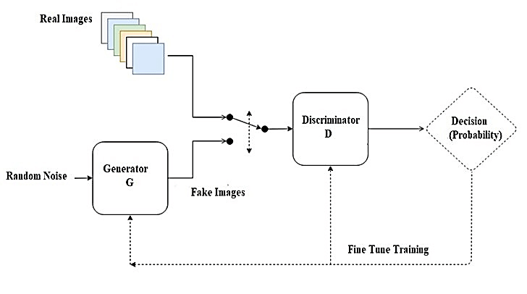Fig.4.4.4 GAN Block Diagram

Application Of Generative Adversarial Networks (GANs)
GANs, or Generative Adversarial Networks, have many uses in many different fields. Here are some of the widely recognized uses of GANs:
- Image Synthesis and Generation : GANs are often used for picture synthesis and generation tasks, They may create fresh, lifelike pictures that mimic training data by learning the distribution that explains the dataset. The development of lifelike avatars, high-resolution photographs, and fresh artwork have all been facilitated by these types of generative networks.
- Image-to-Image Translation : GANs may be used for problems involving image-to-image translation, where the objective is to convert an input picture from one domain to another while maintaining its key features. GANs may be used, for instance, to change pictures from day to night, transform drawings into realistic images, or change the creative style of an image.
- Text-to-Image Synthesis : GANs have been used to create visuals from descriptions in text. GANs may produce pictures that translate to a description given a text input, such as a phrase or a caption. This application might have an impact on how realistic visual material is produced using text-based instructions.
- Data Augmentation : GANs can augment present data and increase the robustness and generalizability of machine-learning models by creating synthetic data samples.
- Data Generation for Training : GANs can enhance the resolution and quality of low-resolution images. By training on pairs of low-resolution and high-resolution images, GANs can generate high-resolution images from low-resolution inputs, enabling improved image quality in various applications such as medical imaging, satellite imaging, and video enhancement.

Advantages of GAN
The advantages of the GANs are as follows:
- Synthetic data generation: GANs can generate new, synthetic data that resembles some known data distribution, which can be useful for data augmentation, anomaly detection, or creative applications.
- High-quality results: GANs can produce high-quality, photorealistic results in image synthesis, video synthesis, music synthesis, and other tasks.
- Unsupervised learning: GANs can be trained without labeled data, making them suitable for unsupervised learning tasks, where labeled data is scarce or difficult to obtain.
- Versatility: GANs can be applied to a wide range of tasks, including image synthesis, text-to-image synthesis, image-to-image translation, anomaly, detection, data augmentation, and others.

Disadvantages of GAN
The disadvantages of the GANs are as follows:
- Training Instability: GANs can be difficult to train, with the risk of instability, mode collapse, or failure to converge.
- Computational Cost: GANs can require a lot of computational resources and can be slow to train, especially for high-resolution images or large datasets.
- Overfitting: GANs can overfit the training data, producing synthetic data that is too similar to the training data and lacking diversity.
- Bias and Fairness: GANs can reflect the biases and unfairness present in the training data, leading to discriminatory or biased synthetic data.
- Interpretability and Accountability: GANs can be opaque and difficult to interpret or explain, making it challenging to ensure accountability, transparency, or fairness in their applications.
4.4.5 AUTOENCODERS:
A type of neural network used for unsupervised learning. They consist of an encoder and a decoder, which are trained to reconstruct input data. The encoder compresses the input data into a latent-space representation, and the decoder reconstructs the original input from this representation. Autoencoders can be used for tasks such as data denoising, dimensionality reduction, and anomaly detection.
4.5 CONFUSION MATRIX
The confusion matrix is a matrix used to determine the performance of the
classification models for a given set of test data. It can only be determined if the
true values for test data are known. The matrix itself can be easily understood,
but the related terminologies may be confusing. Since it shows the errors in the
model performance in the form of a matrix, hence also known as an error matrix.
The four metrics in the confusion matrix are
True Negative (TN): Model has given prediction No, and the real or actual
value was also No.
True Positive (TP): The model has predicted yes, and the actual value was
also true.
False Negative (FN): The model has predicted no, but the actual value was
Yes, it is also called as Type-II error.
False Positive (FP): The model has predicted Yes, but the actual value was No. It is also called a Type-I error.
4.5.1 NEED FOR CONFUSION MATRIX
- It evaluates the performance of the classification models, when they make
predictions on test data, and tells how good our classification model is.
- It not only tells the error made by the classifiers but also the type of errors such as it is either type-I or type-II error.
- With the help of the confusion matrix, we can calculate the different
parameters for the model, such as accuracy, precision, etc.
4.5.2 CALCULATIONS USING CONFUSION MATRIX
1.Classification Accuracy: It is one of the important parameters to determine
the accuracy of the classification problems. It defines how often the model
predicts the correct output. It can be calculated as the ratio of the number of correct predictions made by the classifier to all number of predictions made by the classifiers.
The formula is given below:
Accuracy =$\frac{Number of Correction Predictions}{Total Number of P redictions}$

2.Misclassification rate (Error rate): It is also termed as Error rate, and it
defines how often the model gives the wrong predictions. The value of error
rate can be calculated as the number of incorrect predictions to all number of
the predictions made by the classifier. The formula is given below:

Error Rate = $\frac{False Positives+False Negatives}{True Positives+True Negatives+False Positives+False Negatives}$

3.Precision: It can be defined as the number of correct outputs provided by the
model or out of all positive classes that have predicted correctly by the model,
how many of them were actually true. It can be calculated using the below formula:
Precision = $\frac{True Positives}{True Positives+Flase Positives}$

4.Recall: It is defined as the out of total positive classes, how our model predicted
correctly. The recall must be as high as possible.
Recall = $\frac{True Positivies}{True Positives+False Negatives}$
5.F-measure: If two models have low precision and high recall or vice versa,it is
difficult to compare these models. So, for this purpose, we can use F-score.
This score helps us to evaluate the recall and precision at the same time. The
F-score is maximum if the recall is equal to the precision.It can be
calculated using the below formula:

F1 Score = $\frac{2×Precision×Recall}{Precision+Recall}$

4.6 WORKING ON DEEP LEARNING NETWORKS
Most deep learning methods use neural network architectures, which is why deep learning models are often referred to as deep neural networks.
The term ―deep‖ usually refers to the number of hidden layers in the neural network. Traditional neural networks only contain 2-3 hidden layers, while deep networks can have as many as 150 layers.
Deep learning models are trained by using large sets of labelled data and neural network architectures that learn features directly from the data without any need for manual feature extraction.

4.6.1 TRAIN DEEP LEARNING MODELS
The three most common ways people use deep learning to perform object classification is:
- Training from scratch
To train a deep network from scratch, gather a very large labeled data set and design a network architecture that will learn the features and model. This is good for new applications, or applications that will have a large number of output categories. This is a less common approach because with the large amount of data and rate of learning, these networks typically take days or weeks to train.
- Transfer Learning.
The transfer learning approach is a process that involves fine-tuning a pretrained model. It starts with an existing network, such as Alex Net or Google Net, and feeds in new data containing previously unknown classes. After making some tweaks to the network, you can now perform a new task, such as categorizing only dogs or cats instead of 1000 different objects. This also has the advantage of requiring much less data (processing thousands of images, rather than millions), so computation time drops to minutes or hours.
- Feature Extraction
A slightly less common, more specialized approach to deep learning is to use the network as a feature extractor. Since all the layers are tasked with learning certain features from images, Feature Extraction can pull these features out of the network at any time during the training process. These features can then be used as input to a machine learning model such as Support Vector Machines (SVM).

4.6.2 PURPOSE OF DEEP LEARNING
The Deep Learning models are poised to predict cancer prognosis more accurately and thereby, offering precision and personalized management of the disease. They are better or equivalent to the current approaches in daily clinical practices. It is expected that the deep learning techniques can assist in the proper management of Oral Squamous Cell carcinoma through improved diagnostic performance, insightful clinical decision making, streamline clinicians' work, offering a potential to reduce cancer care costs in the screening, and an effective assessment and surveillance of the disease. Thus, the clinicians and patients can spend more time in communication and in making shared decisions to improve the quality of care. In the future, it is important to develop deep learning models that combine multiple datasets from multiple modalities. depicts the different steps used to detect the Oral Cancer.
- Pre –Processing: - The original image always has few noises due to various reasons. These noises degrade the precision of the diagnosis. Pre-processing is a major function in image process. The anisotropic filter is a filter widely employed for improvement of greyscales images by decreasing noise and improves the configuration of images, specifically edge boundaries.
- Feature Extraction: - It aims to reduce the number of features in a dataset by creating new features from the existing ones (and then discarding the original features). These new reduced set of features should then be able to summarize most of the information contained in the original set of features.
- Feature Selection: -Feature selection is the process of reducing the number of input variables when developing a predictive model. It is desirable to reduce the number of input variables to both reduce the computational cost of modelling and, in some cases, to improve the performance of the model.
- Classifiers: - A Classifier is the algorithm itself – the rules used by machines to classify data. A classification model, on the other hand, is the end result of the classifier's machine learning. The model is trained using the classifier, so that the model, ultimately, classifies the given data.

- discarding the original features). These new reduced set of features should then be able to summarize most of the information contained in the original set of features.
- Feature Selection: -Feature selection is the process of reducing the number of input variables when developing a predictive model. It is desirable to reduce the number of input variables to both reduce the computational cost of modelling and, in some cases, to improve the performance of the model.
- Classifiers: - A Classifier is the algorithm itself – the rules used by machines to classify data. A classification model, on the other hand, is the end result of the classifier's machine learning. The model is trained using the classifier, so that the model, ultimately, classifies the given data.

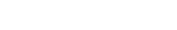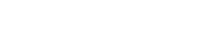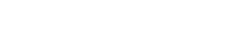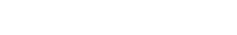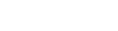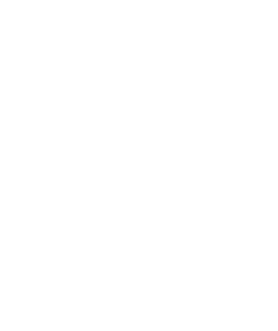

Medical

Image

Medical

Image

Pre
-
Processing

Feature

Extraction

Feature

Selection

Classifier

Cancer

Detection

Cancer

Detection

Deep

Learning

Classifier

Figure 4.6: Flow Chart Showing Different Phases in Detection of Oral Cancer using Deep Learning
4.7 STATEMENT OF THE RESEARCH PROBLEM
A large number of deaths were recorded from oral cancer as a result of lack of its identification and late treatment. The death rate from oral cavity cancerhigh and increasing. It is essential to discover and implement a method to diagnose this cancer in the early stages of detection. It is possible to easily reduce deaths caused by cancer, by detecting it early and enforcing preventive measures. The number of researchers has performed their research in the area of oral cancer diseases but due to the performance improvement still a lot of research can also be performed for the same.

4.7.1 RESEARCH GAP
From review cited by various researchers it has been depicted that:
- Most of the researchers have used limited set of features for extraction and classification purpose, due to this accuracy are not improved in the prior state of the art.
- The detection of oral cancer in the early age is another challenge for the researcher by using different machine learning models.
- Researchers have used SVM, K-means clustering, etc for classification but still there is a scope to use the deep learning neural network for further enhancement of the work.
- In existing approaches very less focus is given on pre-processing. The pre- processing of input data can result in achieving better results.
- The hybrid feature extraction mechanism is another challenge to apply on the proposed work.
So, due to above mentioned gaps existing work proposed a new system that improves the input images by pre-processing and then individual and hybrid optimization is used to validate the results. In this proposed work deep neural network has been used for classification purpose is used.

4.8 NEED OF THE STUDY
Oral cancer is one of the most dangerous which affects and originates from the oral cavity and neck. A large number of deaths were recorded from oral cancer as a result of lack of its identification and late treatment. The death rate from oral cavity cancer is high and increasing. It is essential to discover and implement a method to diagnose this cancer in the early stages of detection. It is possible to easily reduce deaths caused by cancer, by detecting it early and enforcing preventive measures.
Despite various developing therapeutic techniques implemented over the last decades, overall mortality from Oral Cavity Squamous Cell Carcinoma (OCSCC) has not decreased significantly since the 1980s. The obstinate rate of diagnosis with advanced- stage illnesses is due to a lack of screening and early detection efforts. Artificial intelligence (AI), according to experts at the University of Sheffield in the United Kingdom, may help clinicians better estimate patients' risk of oral cancer in this era by ensuring precision, consistency, and objectivity. Deep learning is becoming increasingly important in the medical field as a result of recent advances in computer-aided procedures. An invasive oral biopsy was required during the early stages of OCSCC diagnosis, which was time-consuming and not guaranteed in primary care or community settings, particularly in developing countries, resulting in OCSCC patients receiving delayed diagnosis and referrals. As a result, there is mounting evidence that deep learning algorithms can compete with, if not outperform, human experts in detecting minute visual patterns in photographs. One of the most successful deep learning methods for medical image processing is the convolutional neural network (CNN). It is, however, highly dependent on a variety of factors, including the quality of the training datasets, the number of layers used, the activation function, classification skills, and so on. It is trained with the training dataset to comprehend the dataset's properties, which are then used to extract and categories relevant features. It simplifies and improves the diagnosis of oral tumors.
The objective of the research is to apply the hybrid feature extraction mechanism to dynamically extract the features of all oral type images. And, the proposed optimization method has been applied further to reduce the redundant features and improve the recognition accuracy. Finally, the Deep learning methods have been used for classification. The performance of the proposed system has been compared and tested by using the various parameters such as: accuracy, Specificity and Sensitivity. The primary objective of the research is to build the automatic framework for the detection of oral cancer disease based on deep learning neural network.

CHAPTER 5
SOFTWARE IMPLEMENTATION

5.1 SOFTWARE REQUIREMENTS
- MATLAB 9.10 Version R2021a
5.1.1 MATLAB
MATLAB (MATrix LABoratory) is a numerical computing environment
and fourth-generation programming language. Developed by Math Works,
MATLAB allows matrix manipulations, plotting of functions and data,
implementation of algorithms, creation of user interfaces, and interfacing with
programs written in other languages, including C, C++, Python, Java, and Fortran.
5.1.2 FEATURES OF MATLAB
- High-level language for technical computing.
- Development environment for managing code, files, and data.
- Interactive tools for iterative exploration, design, and problem solving.
- Mathematical functions for linear algebra, statistics, Fourier analysis, filtering, optimization, and numerical integration.
- 2-D and 3-D graphics functions for visualizing data.
- Tools for building custom graphical user interfaces.
- Functions for integrating MATLAB based algorithms with external applications and languages, such as COM, and Microsoft Excel.

  - MATLAB 20a HIGHLIGHTS
LIVE EDITOR ENHANCEMENTS: Improvements in Live Editor, including enhanced code suggestions and completion features, making it easier to write code interactively.
Live Editor Tasks, enabling users to automate common tasks within the Live Editor environment.
MATLAB APP BUILDING: App Designer enhancements, such as improved layout design tools and new UI components, making it easier to create MATLAB apps.Ability to create apps with tabs, allowing for better organization of app interfaces.
MACHINE LEARNING AND DEEP LEARNING: Expanded support for deep learning including improved network training, support for deep learning on 3D image data, and enhanced GPU acceleration.
Updates to the Reinforcement Learning Toolbox, enabling users to design and train reinforcement learning agents.
MATHEMATICS AND DATA ANALYSIS: Improvements to mathematical functions and data analysis capabilities, including updates to spline functions and enhancements in statistical analysis tools.
  - NEW FEATURES IN MATLAB 20a
- Graphics and Visualization
- Simulation Analysis and Performance
- Simulink Editor
- Component -Based Modelling
- Project and File Management
- Data Management
- Block Enhancements
- Connection to Hardware
- MATLAB Function Blocks
- S-Functions
5.4 ADAVANTAGES OF MATLAB OVER OTHER SOFTWARES
- A very large (and growing) database of built-in algorithms for image processing
and computer vision applications
- MATLAB allows you to test algorithms immediately without recompilation. You
can type something at the command line or execute a section in the editor and
immediately see the results, greatly facilitating algorithm development.
- The MATLAB Desktop environment, which allows you to work interactively with
your data, helps you to keep track of files and variables, and simplifies common
programming/debugging tasks
- The ability to read in a wide variety of both common and domain-specific image
formats.
- The ability to call external libraries, such as OpenCV
- Clearly written documentation with many examples, as well as online resources such as web seminars ("webinars").
- Bi-annual updates with new algorithms, features, and performance enhancements
- If you are already using MATLAB for other purposes, such as simulation, optimization, statistics, or data analysis, then there is a very quick learning curve for using it in image processing.
- The ability to process both still images and video.
- Technical support from a well-staffed, professional organization (assuming your maintenance is up-to-date)
- A large user community with lots of free code and knowledge sharing
- The ability to auto-generate C code, using MATLAB Coder, for a large (and growing) subset of image processing and mathematical functions, which you could then use in other environments, such as embedded systems or as a component in other software.

CHAPTER 7
CONCLUSION AND FUTURE ENHANCEMENT
7.1 CONCLUSION
In conclusion, deep learning techniques, including Recurrent Neural Networks (RNNs), Long Short-Term Memory (LSTM), Gated Recurrent Unit (GRU), Generative Adversarial Networks (GANs), and Autoencoders, hold significant promise for oral cancer detection. These models leverage the power of neural networks to analyze complex medical data and extract meaningful features indicative of malignancy. Moreover, confusion matrix analysis provides valuable insights into the performance of these models, enabling researchers and practitioners to evaluate their efficacy comprehensively. By understanding the strengths and limitations of deep learning models through confusion matrix analysis, efforts can be directed towards enhancing their performance and accelerating progress in oral cancer detection.
7.1.1 APPLICATION OF PROPOSED SYSTEM
- To support early detection.
7.2 FUTURE ENHANCEMENTS
In future, with more time and with more comprehensive
architecture models researches can be done in regard to the proposed system
which could make the classification more accurate. Furthermore, a website
or an app for doctors and nurses might be established for a more user-friendly
experience.

